SonarQube – By using SonarQube we can Analyze static code

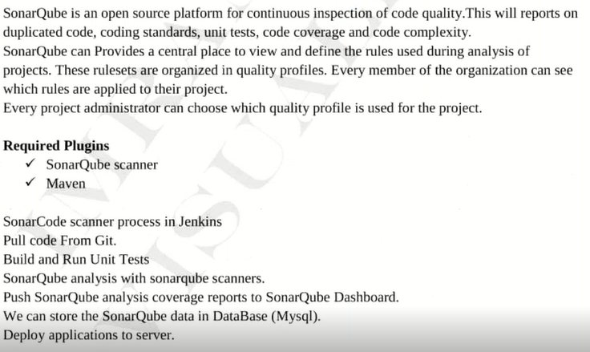



For Sonarqube we have a separate plugin **SonarQube Scaner**

Once static code Analysis is completed those results will save in Database.

We will Integrate SQL DB to SonarQube

By using below command we will connect to EC2 instance which is hosted in Ubuntu Machine in silent mode



>ssh –i “keypair Name.pem” ubuntu@DNS name/Public IP address

If we want to Install any Software in Linux box 1st we have to update Machine 1st (updating Repository) by using below command



It will update Repository

By default along with Unix box we will get some software url’s of path (Updating the repository means if any new version is release related to those s/w those will update in the process of Repository update)